**Juliane Rebecca S. Dayandante BSIT -3C**

**Web Development**

**Documentation**

This is one of the tasks that I worked on, the part 1, where we created a route that accepts a username parameter and displays a welcome message that includes the username.

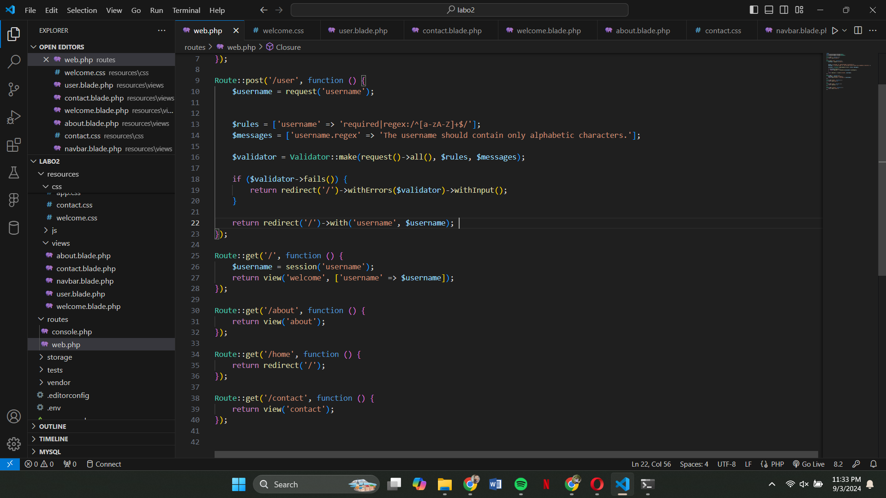

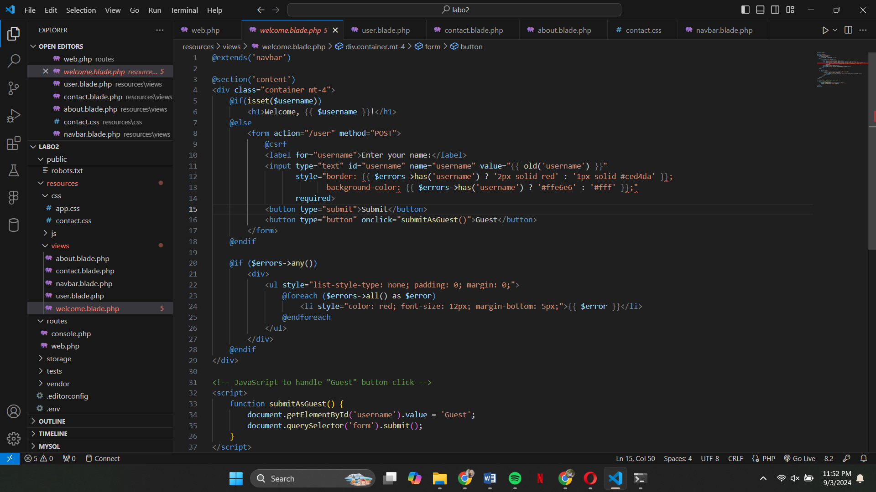

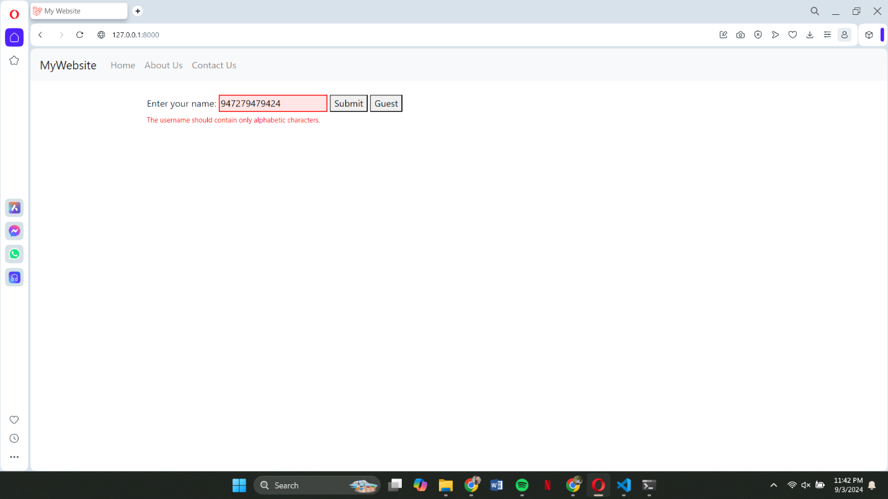This is where I tried to input invalid characters so that I can know if the code that I did for the part 3 is working

This is another one of my part in our website, I was responsible for designing and implementing the Contact page on our website.

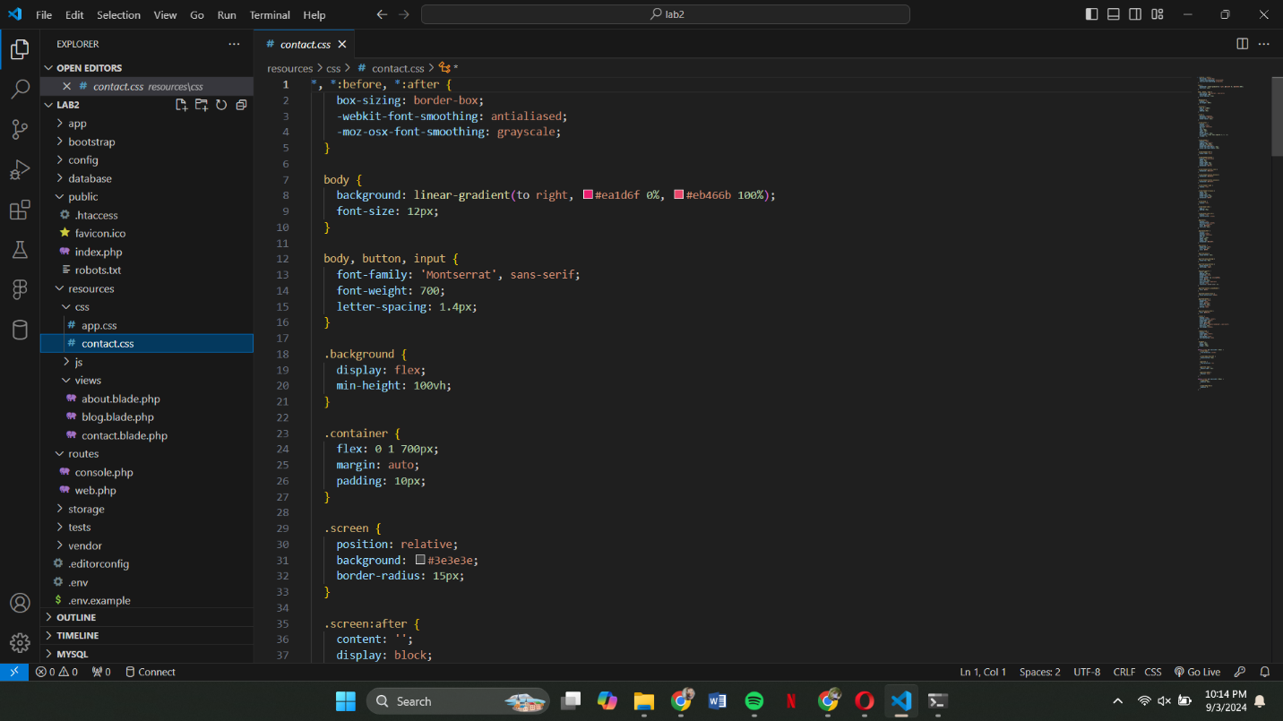

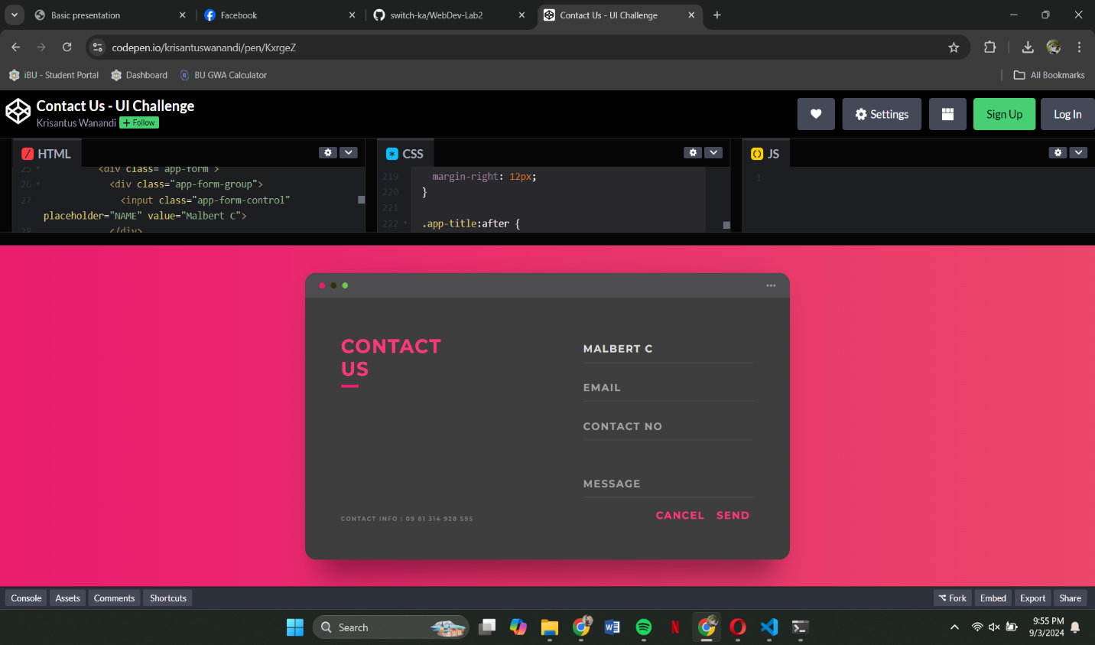

**Pages**

This is the code for entering our username and it also has a Java Script for when you want to be a guest

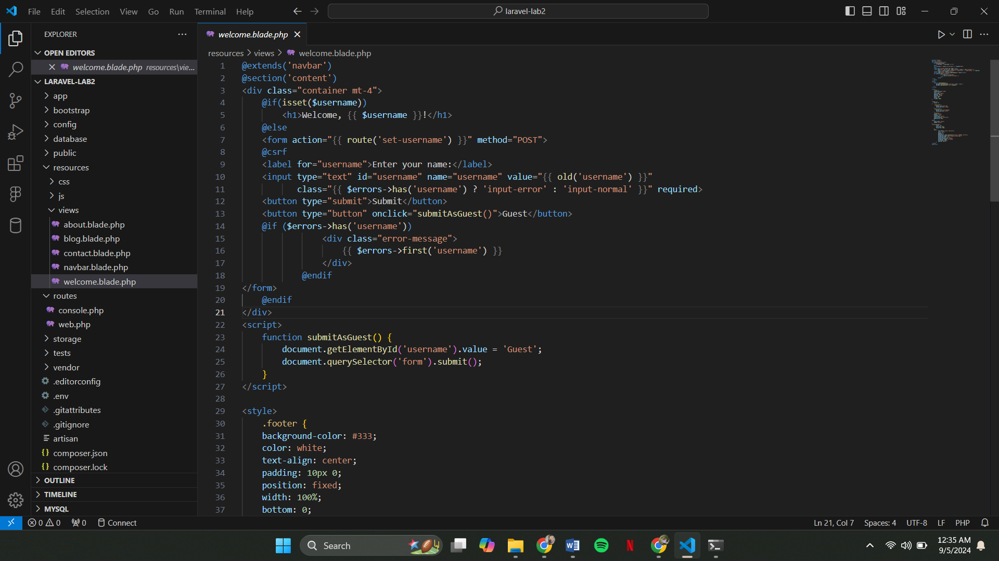

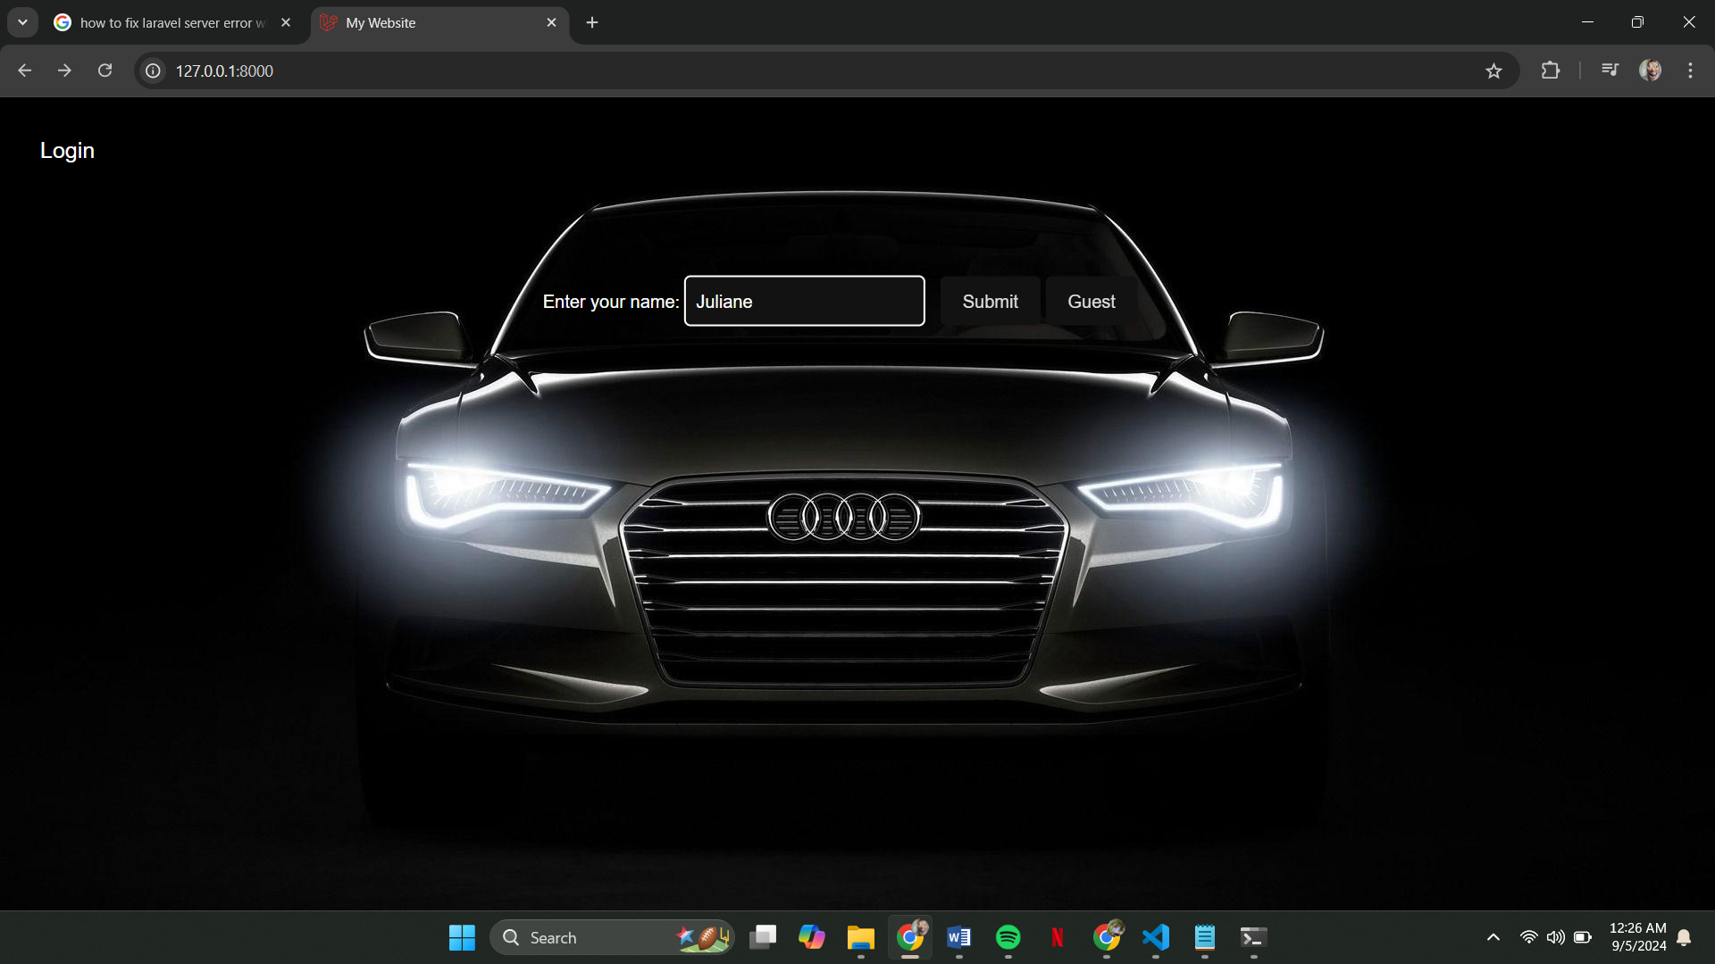This is where you can enter your username, with an option to continue as a guest.

t

After entering your username, you'll be greeted with a personalized welcome message featuring your name.

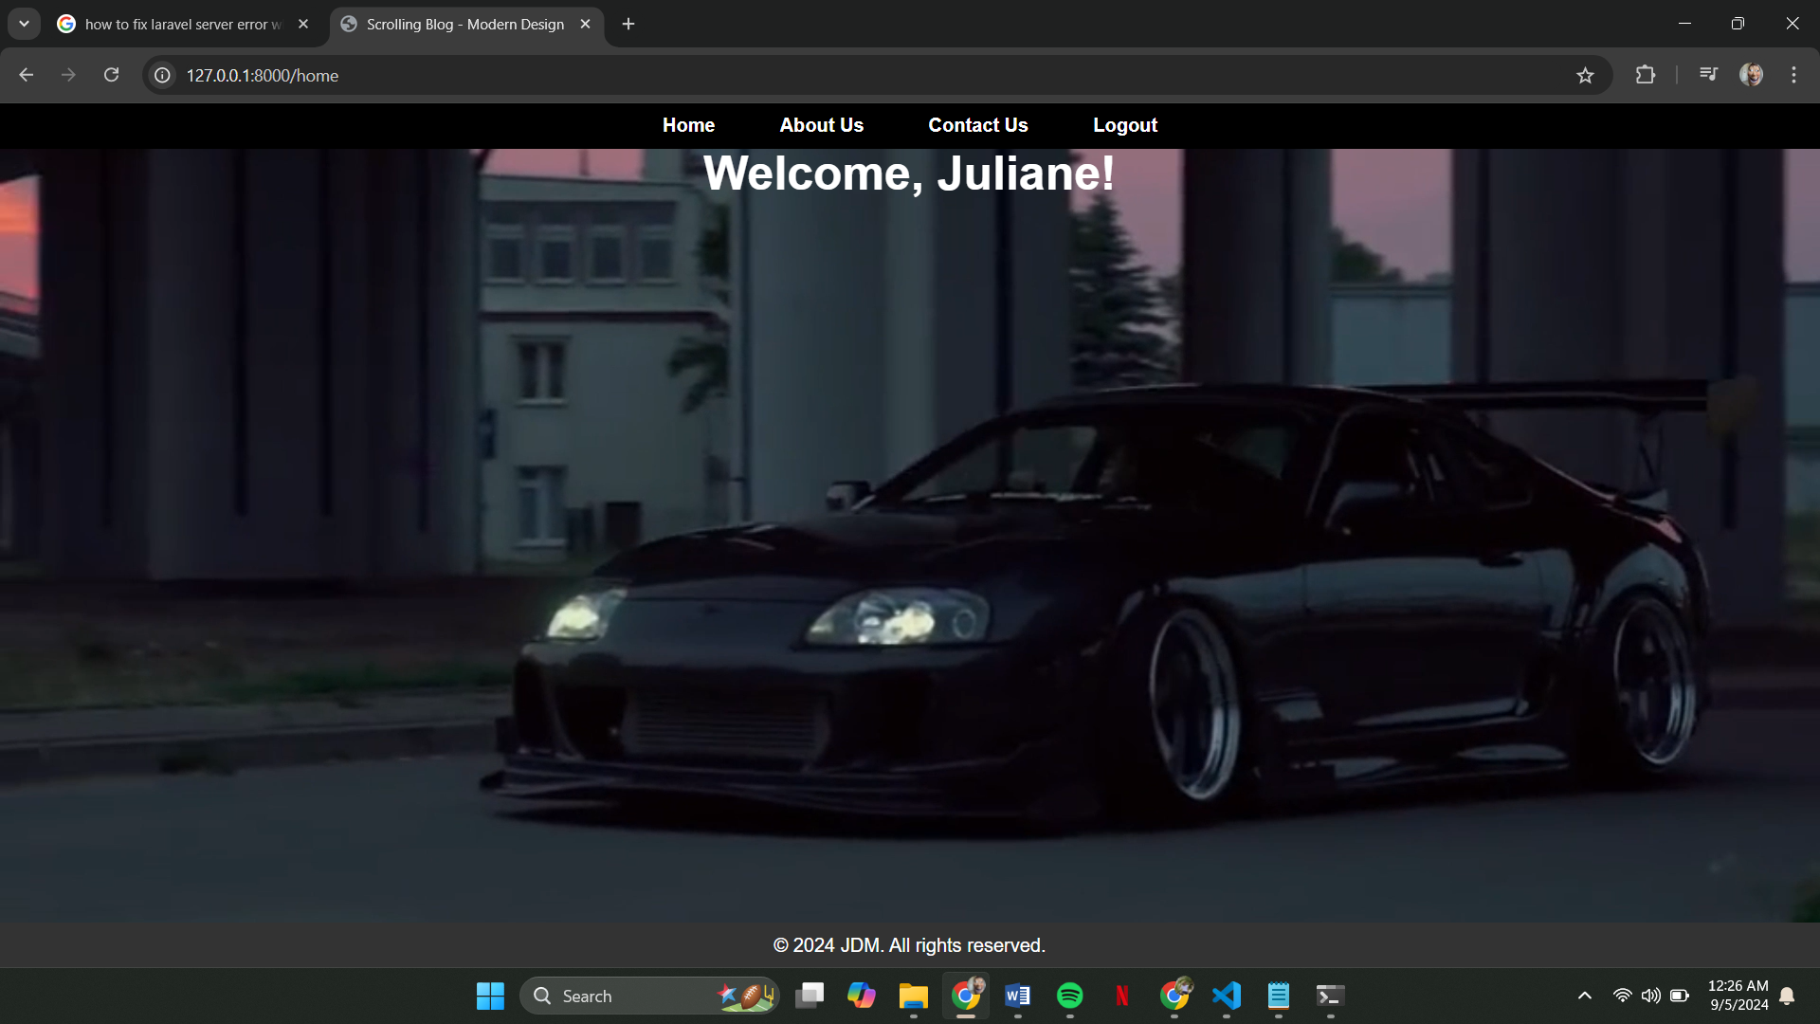

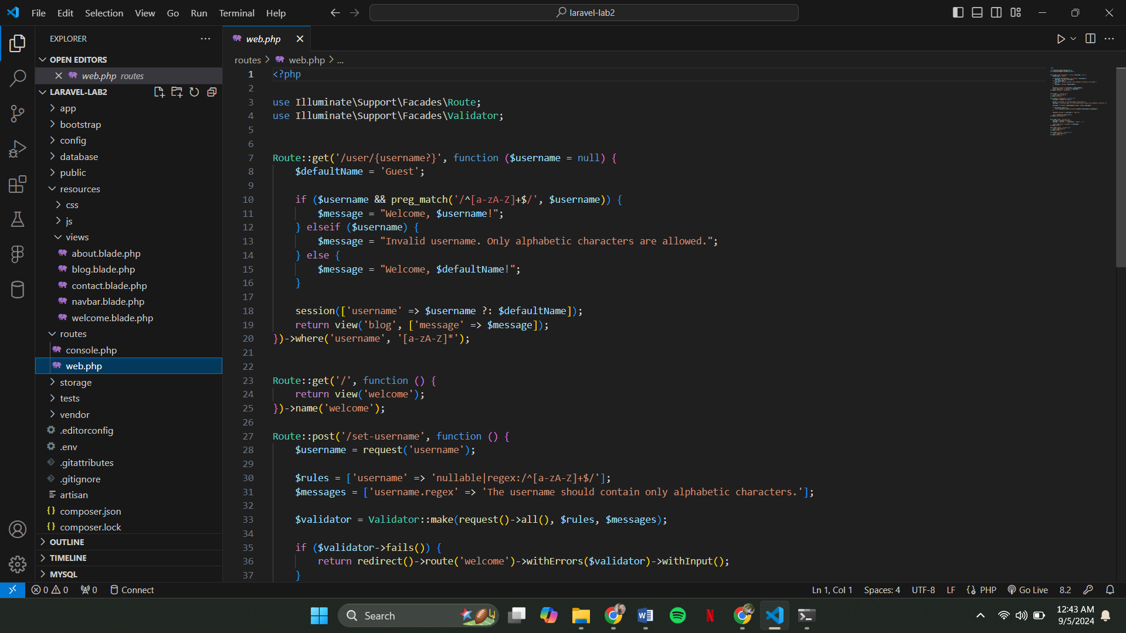

This route handles invalid input by checking if you've entered only alphabetic characters or if you've selected the guest option.

Here’s what it looks like if you chose the guest option.

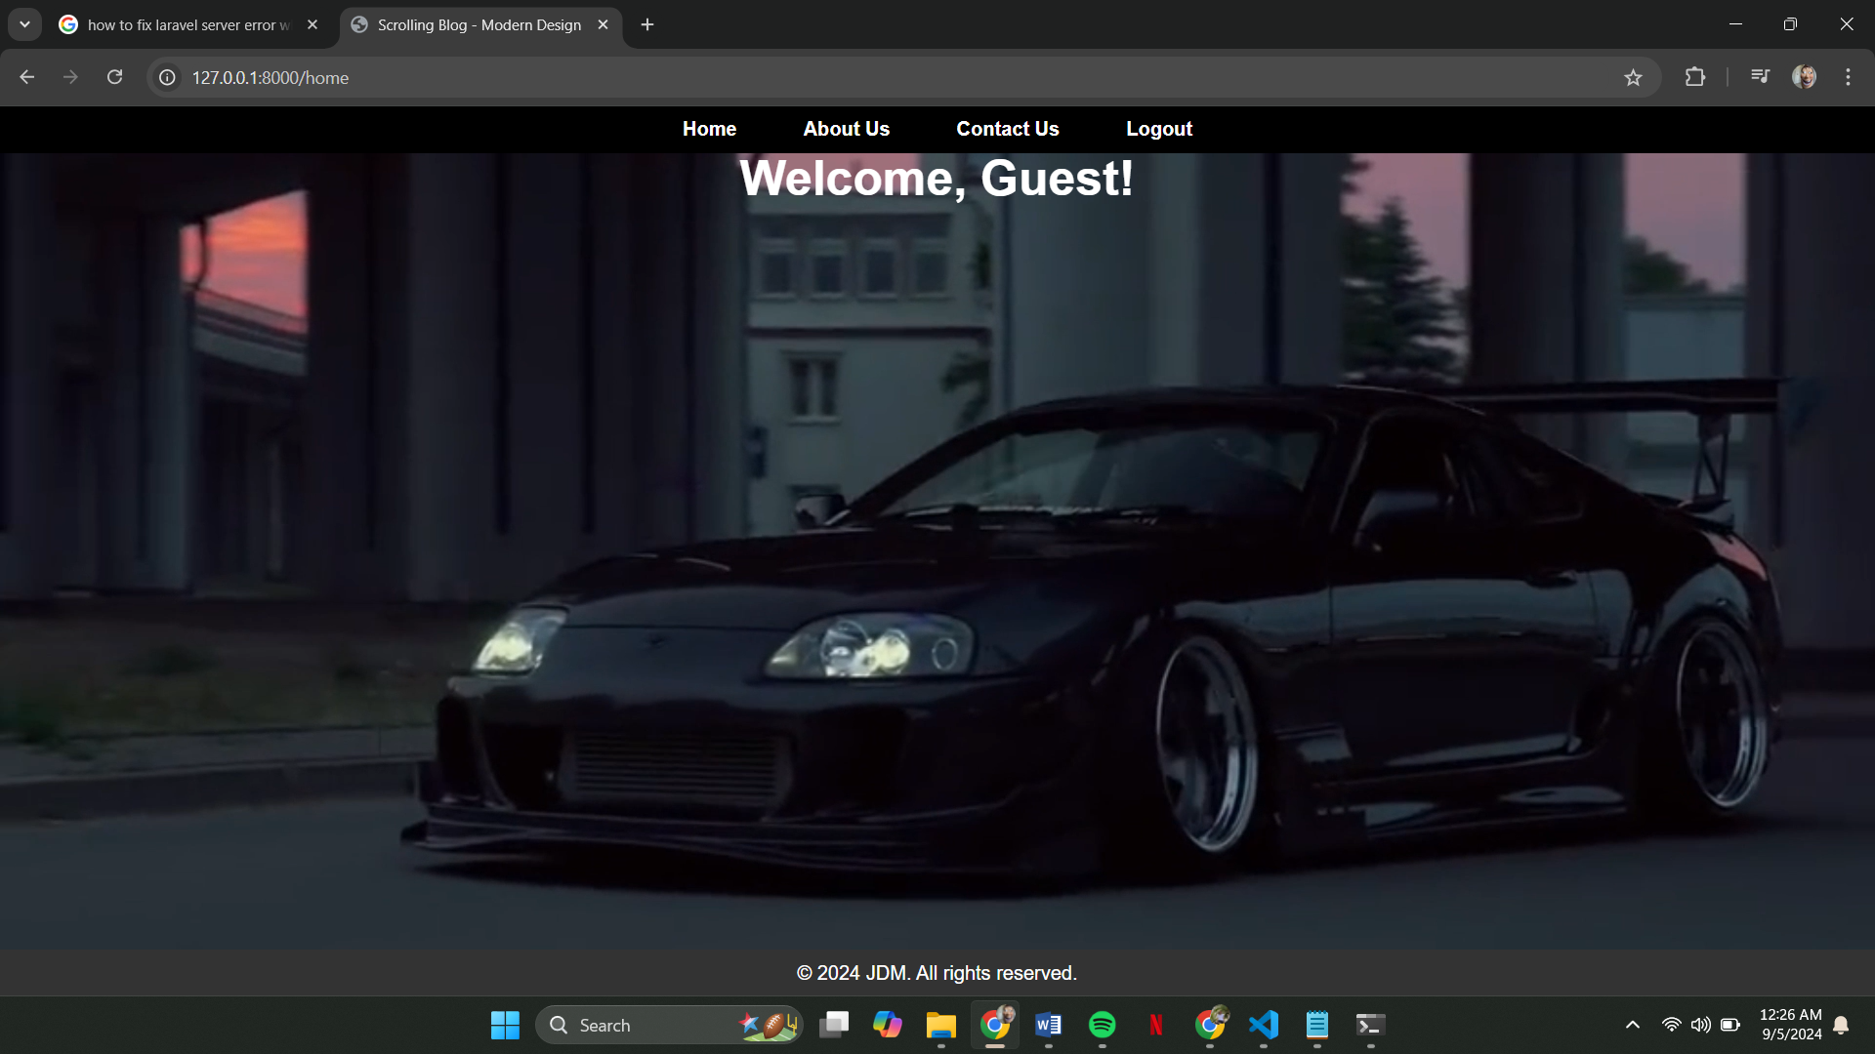

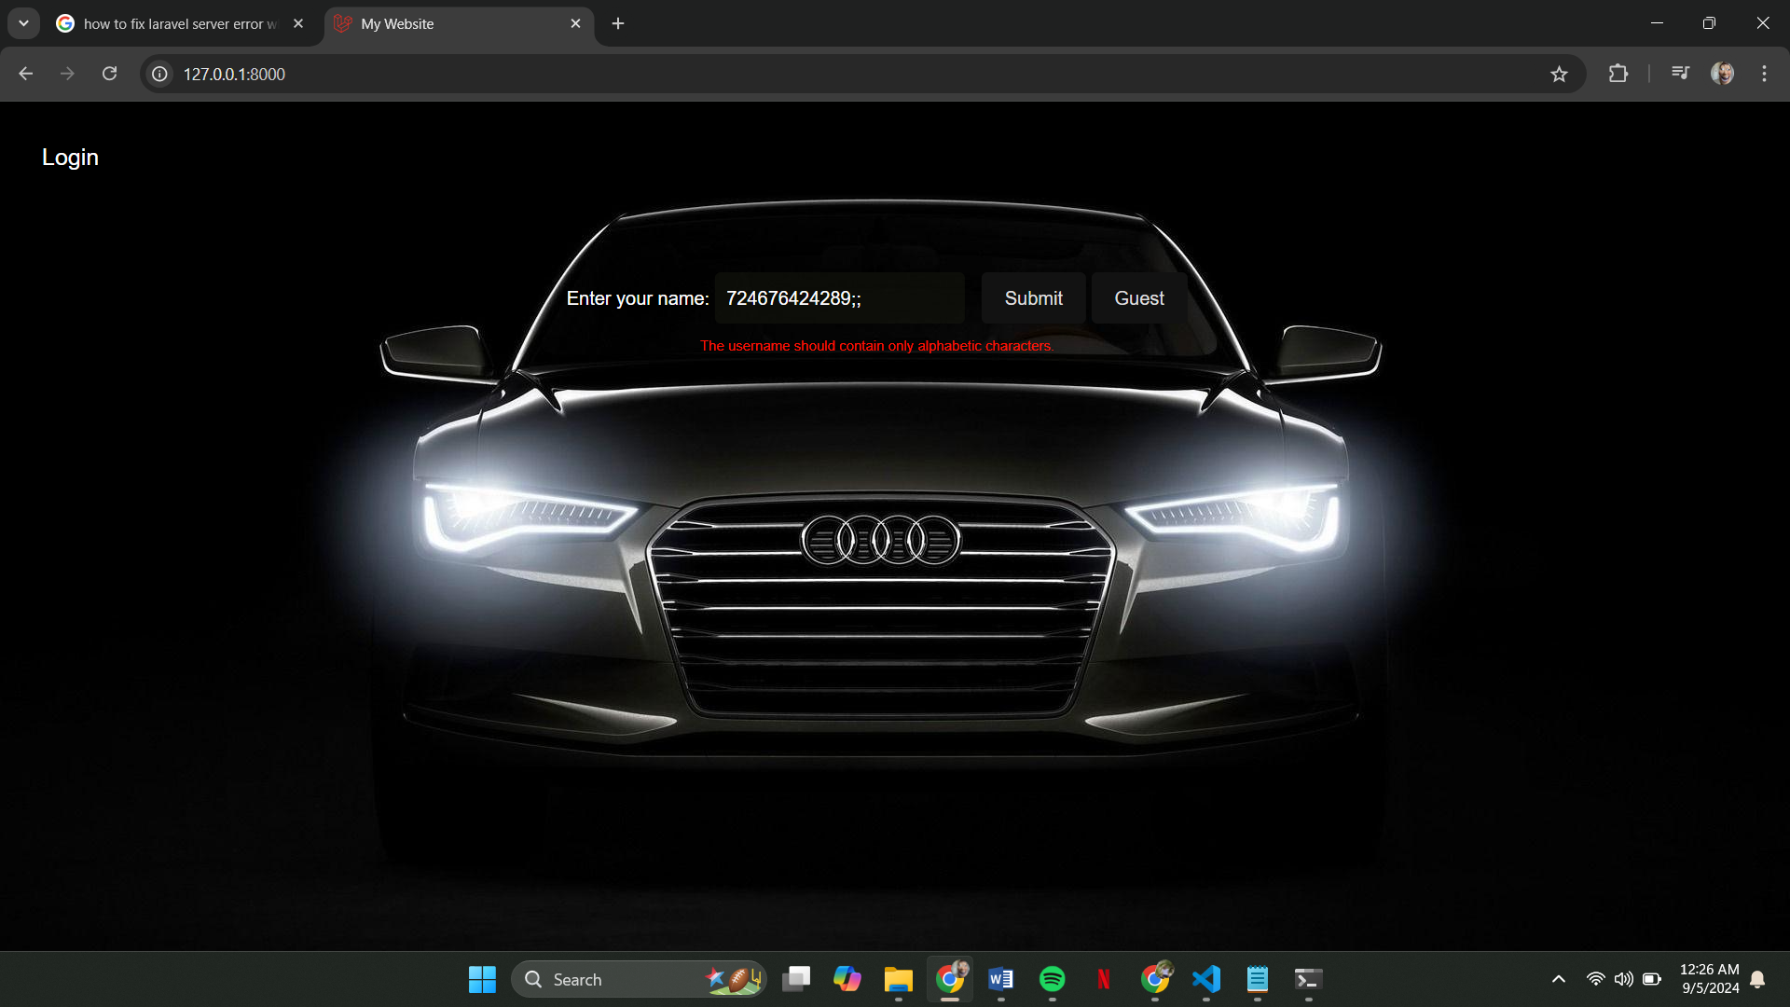This is what it looks like if you entered invalid characters

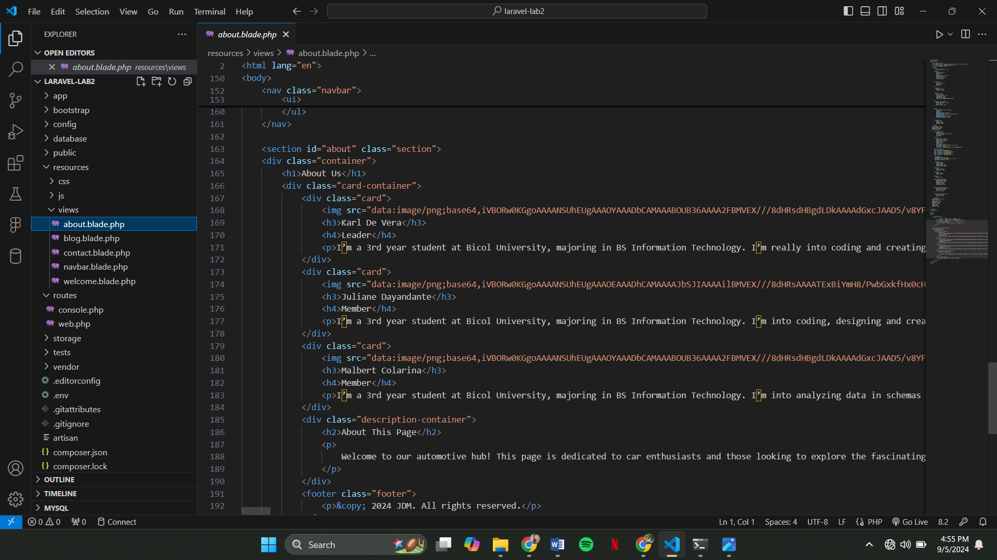This is our code for the “About Us” page, the cards that are here are interactive.

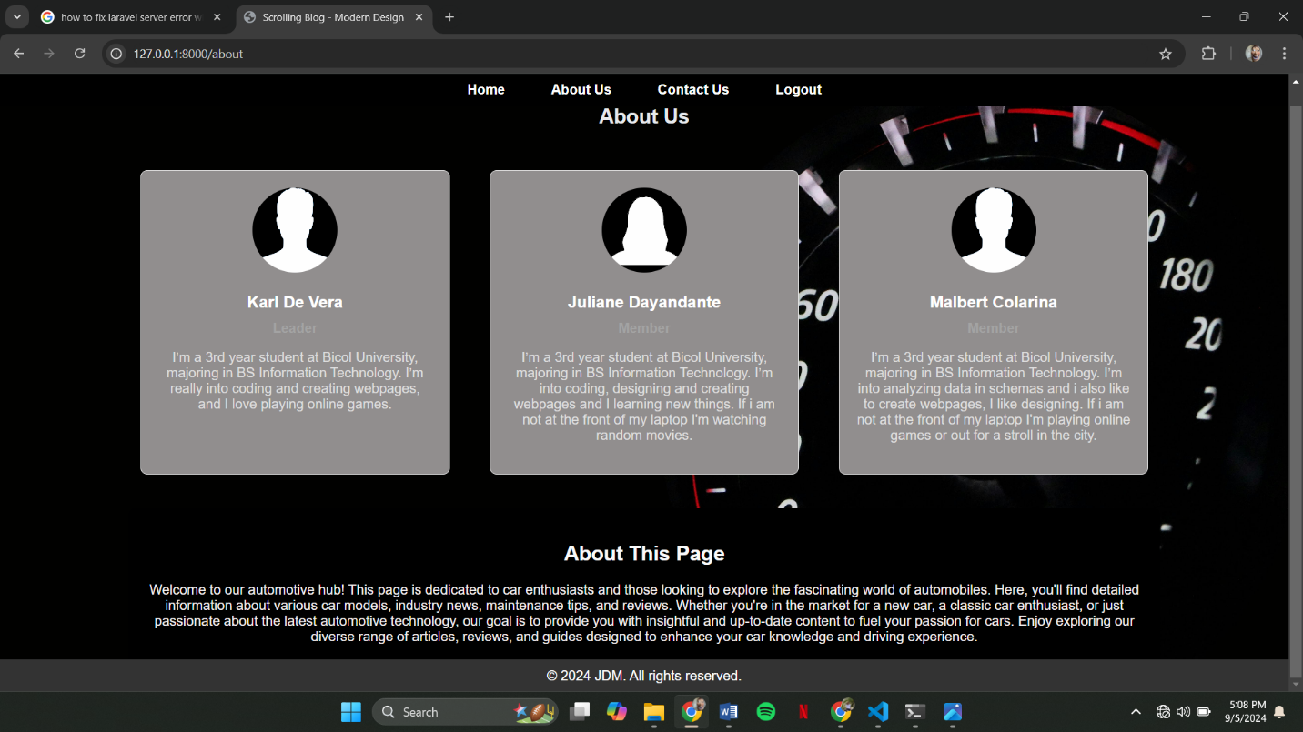

This is how it looks like:

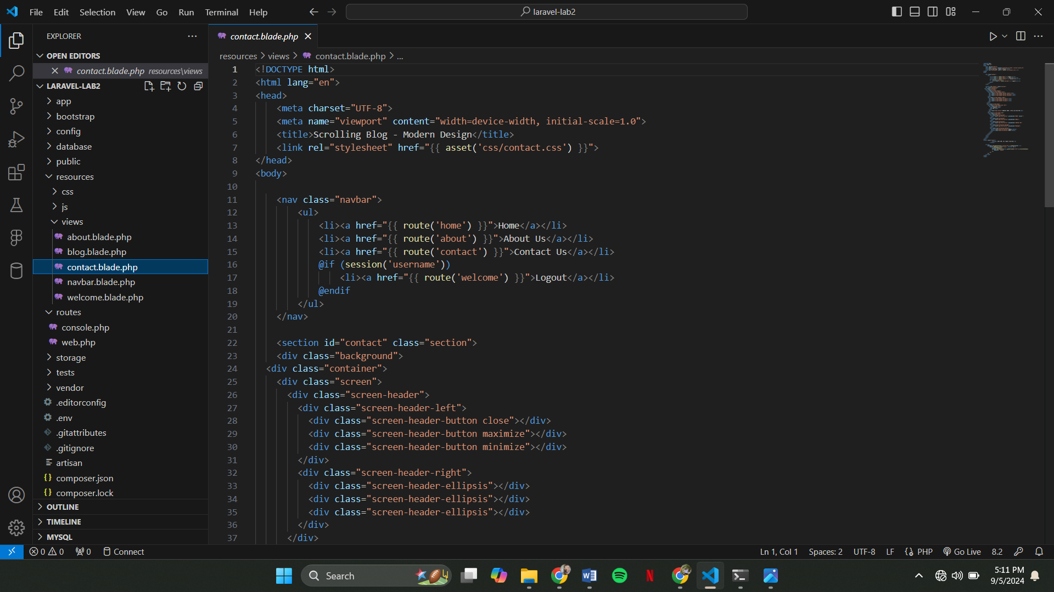This is the code and interface of our “Contact Us” page

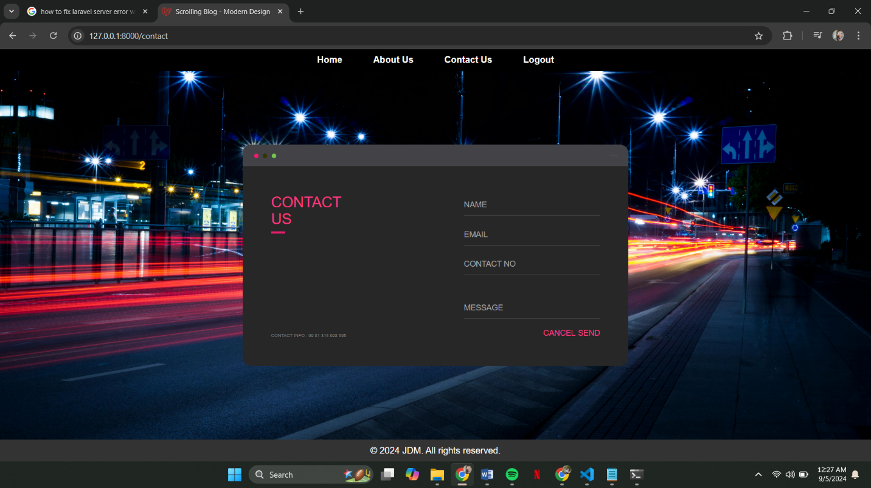

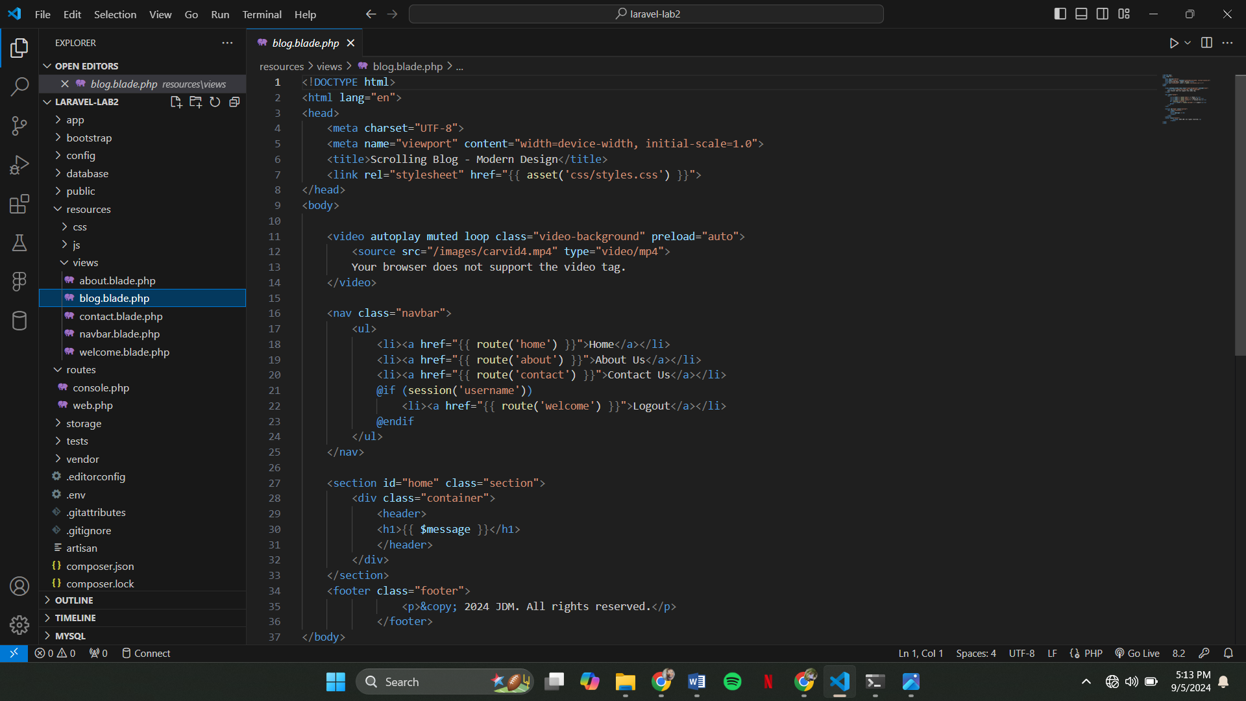

This code is for the moving car in our homepage